**بسمه تعالی**

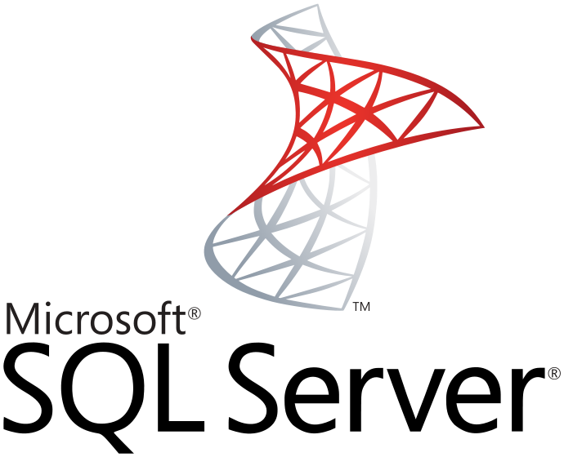

برنامه نویسی بانک اطلاعاتی SQL Server

**نویسنده : محمد حسین فخرآوری**

**فعال سازی**

|  |
| --- |
| sp_configure 'Ole Automation Procedures', 1;  GO  RECONFIGURE; |

**مثال**

|  |
| --- |
| DECLARE @ibj INT;  DECLARE @surl NVARCHAR(200);  DECLARE @res NVARCHAR(4000);  SET @surl = 'https://www.mahimart.com/ApiService/Detail?IdProduct=59';  EXEC sys.sp_OACreate 'WinHTTP.WinHTTPRequest.5.1', @ibj OUT;  EXEC sys.sp_OAMethod @ibj, 'Open', NULL, 'POST', @surl, FALSE;  EXEC sp_OAMethod @ibj,'setRequestHeader',NULL,'Content-Type','application/text; charset=UTF-8';  EXEC sys.sp_OAMethod @ibj, 'send';  EXEC sys.sp_OAGetProperty @ibj, 'responseText', @res OUT;  EXEC sys.sp_OADestroy @ibj;  SELECT @res,LEN(@res); |
| DECLARE @Object AS INT;  DECLARE @ResponseText AS VARCHAR(8000);  DECLARE @surl NVARCHAR(200);  SET @surl = 'https://www.mahimart.com/ApiService/Detail?IdProduct=59';  EXEC sp_OACreate 'MSXML2.XMLHTTP', @Object OUT;  EXEC sp_OAMethod @Object,'open',NULL,'post',@surl, 'false';  EXEC sp_OAMethod @Object, 'send';  EXEC sp_OAMethod @Object, 'responseText', @ResponseText OUTPUT;  EXEC sp_OADestroy @Object;  SELECT @ResponseText; |